**Hirono Artist in Residence 2025 "Takakurayama" Application Form**

**Artist Name:**

**Real Name: (Real name required due to financial transactions)**

**Official Website:**

**Instagram:**

## Resume

### Education

20XX: BFA, XXX University, XXXX Faculty, XXXX Department

20XX: MFA, XXX University, Graduate School, XXXX Department, XXXX Major

### Solo/Two-person Exhibition

20XX [Exhibition Name], [Venue Name], [Location], [Country]

[Exhibition Name], [Venue Name], [Location], [Country]

[Exhibition Name], [Venue Name], [Location], [Country]

Example

2025 Marginal Art Fair Fukushima Hirono, Futatsunuma General Park, Hirono Town, Japan

Note: Except for academic background, list in descending order, meaning the more recent the item, the higher the line. Also, events held in the same year should be listed together.

### Group Exhibition

20XX [Exhibition Name], [Venue Name], [Location], [Country]

[Exhibition Name], [Venue Name], [Location], [Country]

[Exhibition Name], [Venue Name], [Location], [Country

Note: If you choose Selected Group Exhibition, your score will automatically drop, so write as much as you can. Art fairs can also be listed here. You can also write about campus exhibitions.

### Awards and residencies

Year XXXX [Name of Award]

Year XXXX [Name of Artist-in-Residence Invited]

Year XXXX [Name of Grant Received]

Note: Shortlist and Finalist do not be counted as an award. Please only list "First Place" or "Special Prize" (or equivalent, i.e., the highest award received in the competition).

### Public Collections

Please list the names of museums, prominent collections, municipalities, and companies where your work is publicly known to be housed.

### Artist Statement

This is a brief description of the work you are creating as an artist. It is sufficient to simply and clearly describe what you are trying to express, your creative techniques, why you are attempting this, and the experiences and thoughts that are the starting point for your passion. Using complex language will have the opposite effect.)

## Portfolio

The visual materials used by the judges (many of whom are students, residents, or workers in Hirono Town) to assess how well your creative methods are suited to this residency program are referred to as portfolio in this open call.

What we're asking you to show here is "how much of what you can do seems suitable for residency in Hirono Town." Please note that this is not "a complete picture of your creative activities." In other words, the images of your work that you will be pasting into this document should be "a special set of works curated for Hirono Town, specially selected for the judges of Hirono Town's Artist-in-Residence program."

Countless great artists have failed to score well because they missed the point here and tried to show everything they've done. Just as the style of work that's well-received in Tokyo differs from the style that's well-received in New York, the style that will likely receive a high score in the Hirono AIR program is not necessarily the same as the style that will be well-received in Tokyo or London or New York or Berlin.

**Please choose the 5 best images from your past work. If you paste more than six images, you will be immediately disqualified. Combining multiple images into one JPG or PNG will not count as one image. You will be disqualified.**

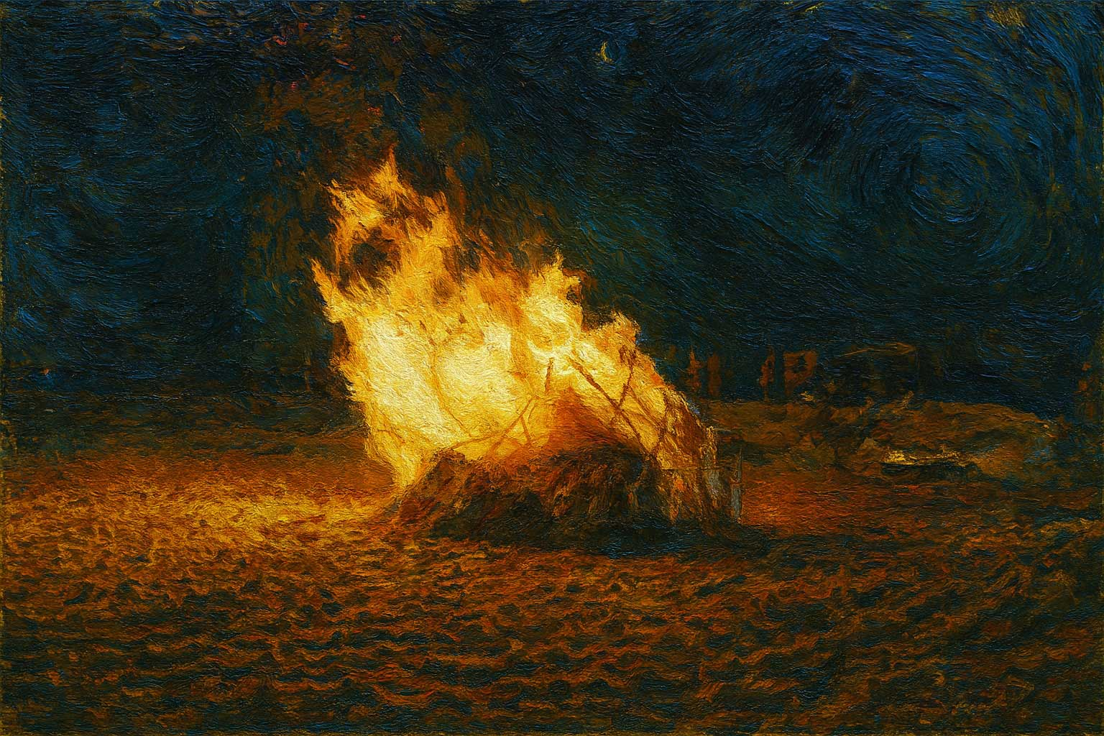

The attached images are dummy; please replace them with images of your own work.

Work 1: "Title"

Year of Creation: (Please arrange from most recent to least recent)

Media: (This refers to the material of the work)

Size: Length XXX cm, Width XXX cm, Height XXX cm

Up to 5 works.

## Residency Project Proposal

Please describe the following in any format:

• How will you conduct your research in Hirono Town?

• What will be your research approach in this AIR?

• How will you turn the findings of your research into your work of art?

• What materials and workspace will you need for the work itself?

It is natural that your research approach and theme will change throughout your residency period, so you do not have to strictly follow what you write here.

## Essay about Hirono Town

In 200-300 words, please freely write about your image of Hirono Town, your thoughts about it, what you hope to gain from your stay in Hirono Town, and how you envision your relationship with Hirono Town in the future.

**! Below is a final check before submitting!**

**☑ Is your resume written correctly? Many people make mistakes, especially when it comes to sorting their resume in descending order, even though they know the correct way. Check it again.**

**☑ Is your artist statement written in true-to-life language? Complicated language won't get the message across.**

**☑ Does your portfolio contain the five best pieces of work that will convey to the judges what you want to create in Hirono Town?**

**☑ Are your residency proposal and essay pasted directly into your application by a generative AI? Don't forget that true-to-life words that convey your breath and warmth are your most powerful weapon.**

**☑ Rename this file to "Hirono AIR2025 Application_YourFullName.docx".**

**☑ Finally, erase all of the notes written in red like this. Leaving any of this information in your application will indicate a lack of administrative ability and result in a significant drop in your score.**